Smart Parking Phase 2 Submission

**Innovation**

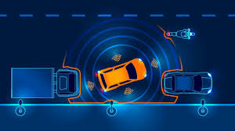

**Introduction:**

In this phase the innovation plan for the smart parking is explained in such a way that is given with a abstract and module in phase 1 submission.

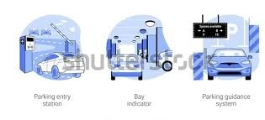

**Design:**

The design of the smart parking includes the IoT devices and software models to provide a best solution for the users who are using the parking to park their vehicles.

In this smart parking we’re using IoT devices and sensors such as infrared, ultrasonic and cameras to detect the availability of the vehicles in the parking slots the placing of the sensors maybe discussed in the development phase.

Use licence plate recognition to identify vehicles and collect data about available spaces, occupancy rates and historical data patterns.

Set up central server to aggregate and process data from sensors utilize data analytics and ML algorithms to predict parking space availability and demand.

Develop a user friendly platform and allow users to find available parking spaces, make reservations and pay for parking and to provide real time parking availability and pricing.

Enable RFID payments, mobile payments or contactless payments for easy and convenient payment.

Implement secure access control measures, such as barriers or gates, to ensure only authorized users can enter or exit the parking areas. Integrate surveillance cameras for security and monitoring

Use smart lightning that adjust brightness based on occupancy. Implement motion sensors to activate lightning only when necessary.

Install Digital signage or LED displays that provide real-time information about parking availability and direction to spots. Use mobile apps to guide users to their reserved parking spaces

Incorporate eco-friendly materials and practices in the design, such as permeable pavements or green parking lots. Promote EV charging stations and support EV Infrastructure.

Integrate the smart parking system with public transportation systems to encourage multimodal commuting and offer discounts or incentives to user who combine public transit with parking.

Regularly maintain and calibrate sensors and equipment to ensure accuracy. Provide customer support and a helpdesk for users who encounter issues or have questions.

